Latest Round-ups:
Season 2019/20
#28
Midweek Action: It was a big night in the First Division on Tuesday where a number of the promotion favourites were in action. All four of the fixtures that took place involved a side who started the week in the top six, with only league leaders Calne Town failing to pick up maximum points. Having won their previous six games in the league, the Lilywhites would have been expected to beat 16th placed Almondsbury, but they succumbed to a surprise 1-0 defeat following Ashley Knight’s 32nd minute goal. Second-placed Sherborne came through a tough test away at Bishop Sutton, striking in the final quarter to eventually win by two goals to one. After leading scorer Alex Murphy had given the Zebras a half-time lead, they conceded ten minutes into the second half against their relegation-threatened hosts. With 20 minutes left on the clock, Haydn Hodges headed home the crucial winner, as Sherborne hung on despite losing keeper Jamie Beale to a red card in the closing stages. Things were a little more straightforward for Wells City who beat Devizes 3-0 at the Athletic Ground to end a two-match winless run. Ross McErlain has recently returned to Wells, and he provided an excellent for the game’s first goal, which was finished well by Craig Herrod. Less than two minutes later, Charlie Crook got his head on a corner to double the home side’s advantage, with leading scorer Harry Foster then adding his name to the scoresheet in stoppage time at the end of a frantic first-half. At the Southfields Rec, Radstock Town secured their sixth win from their last seven league outings, scoring twice after the break to beat Bishops Lydeard 2-0. The Miners have four games in hand on the top four, and cannot be discounted in the race for promotion, with their latest victory coming thanks to goals from Jack Biddiscombe and Josh Howe.

Tuesday also finally saw the completion of the second round in the Les Phillips Cup, with First Division side Cheddar claiming a shock 2-1 victory away at Cribbs. The game had been called off a couple of times, and it is the Cheesemen who will take on Hallen in the last eight thanks to goals either side of the interval from Adam Wright and Ollie Hucker. Cribbs tried manfully to get back into the game, scoring late on Jake Hodgson, but it was too little too late and their attention will turn back to league matters. Elsewhere in the competition, Bridgwater became the first team to book their place in the semi-finals after beating Exmouth Town 3-1 at Fairfax Park. The host’s flew out of the blocks, with efforts from Tom Ellis and Sam Towler helping them storm into a two-goal lead after just 12 minutes. Exmouth responded well to falling behind, and after going close on a couple of occasions, they finally broke through on the half hour when Jordan Harris struck to take his recent tally to four goals from his previous five games. That was as good as it got for the Devon side however, and Bridgwater confirmed their victory in the 62nd minute when Jack Taylor rounded the keeper before rolling the ball into an empty net. In other cup action, Bristol Telephones’ run in the Gloucestershire FA Challenge Trophy ended on Tuesday after they conceded in the 89th minute to lose 1-0 at home to Gala Wilton.

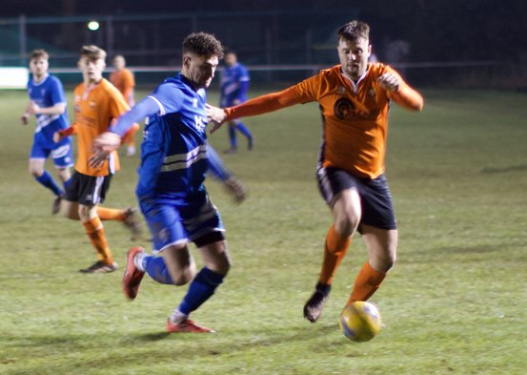
Wednesday saw a pair of Premier Division clashes take place, with Tavistock the night’s big winners, putting four past Roman Glass St George at Oaklands Park. A first-half dismissal didn’t aid the host’s prospects, but Tavistock took full advantage, surging into a three-goal lead at the break thanks to efforts from Josh Grant, Ben Cross and Jack Crago. The red-hot Devon side have now won 11 on the bounce in all competitions, with an own-goal after the interval adding to their winning margin. The other fixture was an entertaining affair between Wellington and Hallen, with the game ending in a 2-2 draw to dent each side’s prospects at either end of the table. Wellington’s fight against relegation looked to have improved in the opening stages on Wednesday after a quick-fire double from recent signing Jesse Howe put the 20th placed side into a two-goal lead. It was very much a game of two halves however, and after Sacha Tong had headed Hallen back into the game, they grabbed an equaliser on the hour mark thanks to a Kyle Thomas penalty after Aaron Anglin had been fouled in the box.
Action from the draw between Wellington and Hallen
FA Vase: Bitton created history, reaching the last eight of the FA Vase for the first time thanks to a 2-1 victory at home to Sutton Common Rovers. The star of the show was Josh Egan, with the diminutive forward striking in either half for the Ton. His first goal, which broke the deadlock after 26 minutes, was a fantastic curling free-kick from well outside the penalty area which gave the visiting keeper no chance. Egan then struck again 15 minutes from time to double Bitton’s advantage after being played in by Karim Rendall. Sutton set up a nervy finish when Adam Allen scored a tap-in two minutes from time, but Bitton managed to hold out for the victory to book their spot in the quarter-finals. Joining them in the next round are Plymouth Parkway, who came from behind to beat West Auckland Town 2-1 in front of a huge crowd at Bolitho Park (pictured right, courtesy of John Pool). After having an effort cleared off the line inside the opening minute, Parkway were hit by a sucker-punch after half an hour when Amar Purewal turned the ball home to put West Auckland in front. With half-time on the horizon, the home side pushed for an equaliser and managed to grab it through Rob Farkins who reacted fastest to a loose ball in the visitors area. Parkway were then given a dream opportunity to go ahead for the first time early in the second half, but leading scorer Adam Carter failed to hold his nerve, blasting his penalty over the bar which had been awarded following a handball in the area. The second goal eventually came for Parkway, with a low poked finish from Billy Palfrey helping them complete the turnaround to thrill many of the 671 fans in attendance. Unfortunately, Bradford Town’s run in the Vase came to an end at the hands of Leighton Town, with Matty Morris’ goal at the end of the first half all the Bobcats had to show during a 3-1 home defeat.
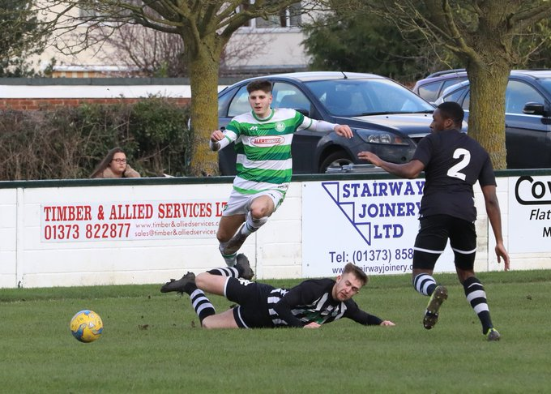
Premier Division: Hallen made a huge statement on Saturday afternoon, beating fellow promotion hopefuls Exmouth Town by four goals to one in Bristol. Following a goalless first half, Hallen shot into life after the break, scoring four goals in the space of 23 minutes to rack up their fourth consecutive home victory. It was Scott Thomas who broke the deadlock in the early stages of the second half, with Matt Davis then heading the hosts two ahead five minutes later. Kyle Thomas continued the dominant passage of play, adding a third, with Aron Robbins then making it 4-0 soon after to help his side smash through the 50-point barrier. Brislington registered their first win since mid-November, scoring twice in the final 25 minutes to beat Cribbs 2-0. After 65 goalless minutes tit was George Box who managed to get his head on a cross into the box from Mark Fear to put the away side in front. With Cribbs pushing for a late equaliser, Brislington took advantage of the extra space, with Tristan Plummer finishing well to double their lead and finally claim the morale-boosting three points. Keynsham have now racked-up back-to-back away victories after defeating Cadbury Heath 3-0 at Springfield. Mike Grist struck in either half for the victorious K’s, with his 41st minute penalty putting them in front, before he added a late third following Matt Brown’s close-range finish 15 minutes from time. Another side to win away from home were Bridgwater, with two goals from the in-form Jack Taylor helping them beat Odd Down 3-2. Taylor opened the scoring after 22 minutes, latching onto a long throw from Tom Ellis before applying the finishing touch. Taylor then struck again from close range to double Bridgy’s lead, before the hosts pulled a goal back to half the deficit. Recent signing Owen Irish restored Town’s two-goal lead thanks to a 62nd minute header, but they were forced to hold off a late challenge from the bottom side who pulled to within a goal once again 14 minutes from time. The clash between Bridport and Roman Glass St George finished in a 2-2 draw, while Street ended Tavistock’s 11-match winning run thanks to a fantastic 2-0 victory at the Tannery Ground. There was also a 2-0 win for Buckland, who scored at the end of either half to beat Wellington. The visitors went ahead in fortunate circumstances five minutes before the interval, with a low cross ricocheting in to the back of the net off Wellington defender Harry Scatchard. Buckland managed to keep their clean sheet intact during the second half, wrapping up their win in the fourth minute of stoppage time when Nathan Cooper made it 2-0. Chipping Sodbury suffered another heavy defeat away at Westbury, conceding three second half goals during their 4-1 loss. It looked like it could be a long afternoon for the visitors when they fell behind in the fifth minute to Ryan Bole’s opener, but to their credit they kept their hosts at bay for the remainder of the half. Westbury came out firing after the interval, increasing their lead through goals from Jordan Pinder and Callum Demkiv, before Dan Price added the finishing touches in stoppage time to make it back-to-back 4-1 wins.
Action from Westbury’s resounding 4-1 victory over Chipping Sodbury Town courtesy of Martin Pearce.

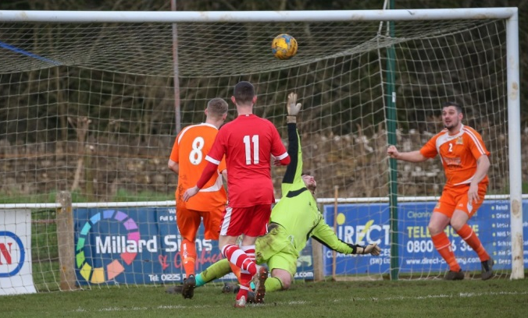
First Division: Sherborne Town have moved into joint ownership of the First Division lead after beating Almondsbury 3-1 at Raleigh Grove. The in-form Zebras fell behind on Saturday, with Greg Parr firing home from the penalty spot following a foul on Stuart Alexander, before Ashley Clarke equalised in the run-up to half-time. Clarke’s second header of the afternoon made it 2-1 ten minutes into the second half, before Josh Williams added a penalty soon after to confirm Sherborne’s fifth consecutive league victory. Sherborne have joined Calne on 50 points atop the division after the Lilywhites fell to a 2-0 defeat away at sixth-placed Radstock. Goals either side of the break from James Rustell and Morgan Marsh handed the Miners victory in a reverse of the 2-0 loss Radstock suffered at the hands of Calne to open the season back in August. In an increasingly unpredictable title race, Wells City are in third spot, two points behind the top two thanks to a 4-0 victory at home to Portishead Town. Harry Foster continues to lead the line with aplomb for the Somerset side, and his goal in first half stoppage time was the difference between the sides at the interval. Tom Hill then doubled Wells’ lead ten minutes into the second half, before Ross McErlain and Charlie Crook each struck in the closing stages to round out the comfortable home win. Another outfit riding high right now are Ashton & Backwell United, who have now won seven of their last eight league fixtures after coming from behind to beat Wincanton 2-1. Mid-table Wincanton suffered a heavy home defeat last weekend, but they made a strong start at the Lancer Scott Stadium, taking a deserved 26th minute lead from the spot through Dan Wise. Ashton responded well to the early setback, and they managed to grab a share of the half-time spoils when James White produced an excellent half-volley to draw the home side level. White was then at it again during the second-half, finishing well to complete the turnaround for fifth-placed United. Another side very much in the title race are Longwell Green Sports, and their return to form continued at home to Welton Rovers, where a Luke Bryan strike was enough to claim a 1-0 win. Things weren’t as close at Lakeview where Hengrove Athletic scored four for the first time in the league this season to claim a comfortable win over Bishop Sutton. The away side got the ball rolling early, grabbing a ninth minute lead from the penalty spot through Jack Jones before Will Harvey made it 2-0 five minutes before the break. Shaun Trott’s powerful header extended Hengrove’s lead even further on the hour mark, before a late own goal from Kai Long completed the scoring. Corsham went one better than Hengrove, with Josh Bright bagging a hat-trick in their one-sided 5-0 triumph over Bristol Telephones. A goal inside the opening ten minutes from Ben Wickens gave Corsham a dream start, before Bright opened his account in the 17th minute to put the hosts in control of the contest. An own-goal stretched the lead to three, before Bright wrapped-up an excellent individual performance, scoring twice in the final nine minutes to complete his goalscoring treble. Cheddar backed-up their excellent midweek cup win with a 4-1 victory over Devizes Town at Nursteed Road. There was plenty of early action in the day’s early kickoff, with goals from Dean Griffiths and Callum Laird putting the Cheesemen two goals ahead inside quarter of an hour. After Devizes struck, an own-goal at the end of the first half restored Cheddar’s two-goal advantage, before Adam Wright dispatched a penalty soon after the break to register another away win. At Castle Road, Tom Summerhill scored in either half to help Oldland Abbotonians beat Warminster 3-1, while Lebeq picked up their tenth league victory of the season by defeating Bishops Lydeard 1-0.
Action from Corsham’s 5-0 victory over Bristol Telephones , courtesy of John Cuthbertson
Western League Statistical Leaders

PREMIER DIVISION LEADING GOAL SCORERS (League only):
Adam Carter (Plymouth Parkway) – 27
Jack Fillingham (Shepton Mallet) – 20
Jordan Harris (Exmouth Town) – 18
Mikey Williams (Plymouth Parkway) – 16
Jack Taylor (Bridgwater Town) – 15
Leighton Thomas (Street) – 14

PREMIER DIVISION TOP ATTENDANCES:
Plymouth Parkway 2 Tavistock 3, Thursday 26th December 2019 - 564
Bridport 0 Bridgwater Town 6, Sunday 6th October 2019 – 347
Wellington 0 Exmouth Town 2, Sunday 6th October 2019 - 315

FIRST DIVISION LEADING GOAL SCORERS (League only):
Harry Foster (Wells City) – 23
James Rustell (Radstock Town) – 19
Stuart Windsor (Calne Town) – 17
Alex Murphy (Sherborne Town) – 14
Dhani Golding (Bristol Telephones) – 11
Toby Cole (Wincanton Town) – 11
Danny Carter (Longwell Green Sports) – 11
Jamal Chevolleau (Corsham & Calne Town) – 11

FIRST DIVISION TOP ATTENDANCES:
Warminster Town 2 Bristol Telephones 3, Saturday 5th October 2019 - 369
Longwell Green Sports 1 Oldland Abbotonians 2, Saturday 28th December 2019 - 289
Portishead Town 3 Longwell Green Sports 5, Saturday 5th October 2019 – 262

LEADING SCORERS IN ALL COMPETITIONS:
Jack Crago (Tavistock) - 33
Harry Foster (Wells City) – 30
Adam Carter (Plymouth Parkway) – 27
Jack Fillingham (Shepton Mallet) – 25
James Rustell (Radstock Town) – 24
Jack Taylor (Bridgwater Town) – 23
Jordan Harris (Exmouth Town) - 21

*All goalscoring stats via Full-Time FA website

Latest Results
Tuesday 4th February 2020
First Division
Almondsbury 1-0 Calne Town 51
Bishop Sutton 1-2 Sherborne Town 25
Radstock Town 2-0 Bishops Lydeard 54
Wells City 3-0 Devizes Town 33
Les Phillips Cup – Second Round
Cribbs 1-2 Cheddar
Les Phillips Cup – Quarter Final
Bridgwater Town 3-1 Exmouth Town 132
GFA Challenge Trophy – Third Round
Bristol Telephones 0-1 Gala Wilton 22
Wednesday 5th February 2020
Premier Division
Roman Glass St George 0-4 Tavistock 45
Wellington 2-2 Hallen 52
Saturday 8th February 2020
FA Vase – Fifth Round
Bitton 2-1 Sutton Common Rovers 209
Bradford Town 1-3 Leighton Town
Plymouth Parkway 2-1 West Auckland Town 671
Premier Division
Bridport 2-2 Roman Glass St George 96
Cadbury Heath 0-3 Keynsham Town 52
Cribbs 0-2 Brislington
Hallen 4-1 Exmouth Town 117
Odd Down 2-3 Bridgwater Town 52
Street 2-0 Tavistock 96
Wellington 0-2 Buckland Athletic 51
Westbury United 4-1 Chipping Sodbury Town 86
First Division
Ashton & Backwell United 2-1 Wincanton Town 88
Bishop Sutton 0-4 Hengrove Athletic 52
Corsham Town 5-0 Bristol Telephones 72
Devizes Town 1-4 Cheddar 48
Lebeq United 1-0 Bishops Lydeard 20
Longwell Green Sports 1-0 Welton Rovers 110
Oldland Abbotonians 3-1 Warminster Town 42
Radstock Town 2-0 Calne Town 72
Sherborne Town 3-1 Almondsbury 70
Wells City 4-0 Portishead Town 50
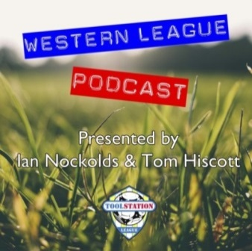
Be sure to check out the latest podcast, where Ian, Tom & guests recap all the latest news and results from around the Western League. To follow along all season, each broadcast will be available at the following link: http://www.toolstationleague.com/podcasts.php

Upcoming Fixtures
Tuesday 11th February 2020
Premier Division
Buckland Athletic vs Plymouth Parkway 19:30KO
Street vs Clevedon Town 19:30KO
First Division
Longwell Green Sports vs Ashton & Backwell United 19:30KO
Portishead Town vs Calne Town 19:30KO
Welton Rovers vs Sherborne Town 19:30KO
Wincanton Town vs Corsham Town 19:30KO
GFA Challenge Trophy – Quarter Final Round
Bitton vs Wick 19:30KO
Cribbs Reserves vs Lebeq United 19:45KO
Hallen vs Oldland Abbotonians 19:30KO
Somerset FA Premier Cup – Quarter Final Round
Hengrove Athletic vs Cheddar 19:30KO
Wednesday 12th February 2020
Premier Division
Bradford Town vs Shepton Mallet 19:30KO
Cadbury Heath vs Tavistock 19:30KO
Exmouth Town vs Cribbs 19:45KO
First Division
Oldland Abbotonians vs Bishops Lydeard 19:45KO
Radstock Town vs Bristol Telephones 19:30KO
Saturday 15th February 2020 (KICK OFF AT 3.00PM UNLESS NOTED)
Premier Division
Bradford Town vs Roman Glass St George
Brislington vs Hallen
Buckland Athletic vs Street
Chipping Sodbury Town vs Cadbury Heath
Exmouth Town vs Westbury United
Keynsham Town vs Bitton
Odd Down vs Cribbs
Plymouth Parkway vs Bridgwater Town
Shepton Mallet vs Bridport
Tavistock vs Wellington
First Division
Almondsbury vs Corsham Town
Bishops Lydeard vs Ashton & Backwell United
Bristol Telephones vs Longwell Green Sports
Cheddar vs Wells City
Devizes Town vs Oldland Abbotonians 14:00KO
Hengrove Athletic vs Calne Town
Lebeq United vs Sherborne Town 15:15KO
Portishead Town vs Radstock Town
Warminster Town vs Bishop Sutton
Wincanton Town vs Welton Rovers

League Tables
Premier Division
 |  | P | W | D | L | F | A | GD | PTS
1 | Bradford Town | 21 | 18 | 1 | 2 | 67 | 19 | 48 | 55
2 | Plymouth Parkway | 20 | 17 | 1 | 2 | 71 | 19 | 52 | 52
3 | Hallen | 25 | 16 | 4 | 5 | 56 | 38 | 18 | 52
4 | Shepton Mallet | 23 | 15 | 3 | 5 | 50 | 35 | 15 | 48
5 | Tavistock | 21 | 15 | 2 | 4 | 54 | 25 | 29 | 47
6 | Exmouth Town | 21 | 15 | 2 | 4 | 50 | 21 | 29 | 47
7 | Bridgwater Town | 25 | 13 | 6 | 6 | 63 | 37 | 26 | 45
8 | Bitton | 21 | 13 | 1 | 7 | 57 | 32 | 25 | 40
9 | Clevedon Town | 25 | 12 | 4 | 9 | 53 | 50 | 3 | 40
10 | Street | 27 | 11 | 4 | 12 | 56 | 60 | -4 | 37
11 | Westbury United | 26 | 11 | 3 | 12 | 49 | 38 | 11 | 36
12 | Keynsham Town | 26 | 10 | 3 | 13 | 46 | 53 | -7 | 33
13 | Buckland Athletic | 21 | 10 | 2 | 9 | 38 | 42 | -4 | 32
14 | Brislington | 24 | 9 | 4 | 11 | 35 | 55 | -20 | 31
15 | Roman Glass St George | 24 | 8 | 4 | 12 | 52 | 41 | 11 | 28
16 | Cadbury Heath | 27 | 6 | 7 | 14 | 31 | 64 | -33 | 25
17 | Cribbs | 24 | 7 | 2 | 15 | 33 | 58 | -25 | 23
18 | Bridport | 25 | 5 | 2 | 18 | 35 | 80 | -45 | 17
19 | Chipping Sodbury Town | 26 | 5 | 1 | 20 | 29 | 84 | -55 | 16
20 | Wellington | 27 | 3 | 3 | 21 | 24 | 67 | -43 | 12
21 | Odd Down | 25 | 3 | 1 | 21 | 22 | 69 | -47 | 10

First Division
 |  | P | W | D | L | F | A | GD | PTS
1 | Calne Town | 24 | 16 | 2 | 6 | 42 | 18 | 24 | 50
2 | Sherborne Town | 24 | 16 | 2 | 6 | 56 | 33 | 23 | 50
3 | Wells City | 24 | 14 | 6 | 4 | 64 | 27 | 37 | 48
4 | Longwell Green Sports | 24 | 15 | 3 | 6 | 58 | 35 | 23 | 48
5 | Ashton & Backwell United | 23 | 13 | 6 | 4 | 38 | 36 | 2 | 45
6 | Radstock Town | 20 | 14 | 1 | 5 | 49 | 26 | 23 | 43
7 | Corsham Town | 24 | 12 | 3 | 9 | 41 | 45 | -4 | 39
8 | Oldland Abbotonians | 21 | 10 | 5 | 6 | 29 | 32 | -3 | 35
9 | Cheddar | 22 | 10 | 4 | 8 | 38 | 34 | 4 | 34
10 | Bishops Lydeard | 22 | 10 | 3 | 9 | 48 | 35 | 13 | 33
11 | Wincanton Town | 19 | 10 | 2 | 7 | 36 | 40 | -4 | 32
12 | Lebeq United | 23 | 10 | 0 | 13 | 47 | 54 | -7 | 30
13 | Hengrove Athletic | 24 | 8 | 4 | 12 | 21 | 46 | -25 | 28
14 | Warminster Town | 23 | 8 | 2 | 13 | 41 | 38 | 3 | 26
15 | Portishead Town | 23 | 7 | 4 | 12 | 40 | 43 | -3 | 25
16 | Almondsbury | 22 | 7 | 4 | 11 | 31 | 37 | -6 | 25
17 | Welton Rovers | 24 | 6 | 4 | 14 | 27 | 44 | -17 | 22
18 | Devizes Town | 23 | 3 | 6 | 14 | 33 | 54 | -21 | 15
19 | Bishop Sutton | 23 | 3 | 3 | 17 | 25 | 52 | -27 | 12
20 | Bristol Telephones | 22 | 2 | 2 | 18 | 28 | 63 | -35 | 8

